# Maria’s Code: Improve UI (HTML + CSS + Effects)

Maria is the team’s front-ender, so she wants to **improve the look and feel** of the project (**CSS** styles + add some **JS effects** + improve the **HTML** in order to be able to style it):

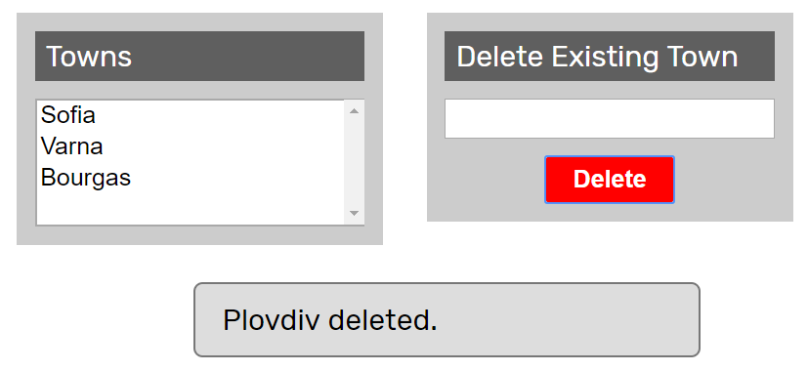

She **clones** the project repository, makes a sequence of **changes** in the source code files, **commits** locally in his repository, then **pushes** the committed changes to GitHub.

## Clone the “Towns” Repository

Maria starts by **cloning** the project repository:

|  |
| --- |
| git clone https://github.com/SoftUni/towns |

## Improve the HTML Structure

Maria wants to style the site to look better but the **HTML structure** does not allow writing CSS, so she modifies towns.html and introduces a new way to structure the content as a sequence of **articles** holding **headers** and other elements after the header:

|  |
| --- |
| <article>  <header>Towns</header>  <select id="towns" size="4">  <option>Sofia</option>  <option>Plovdiv</option>  <option>Varna</option>  <option>Bourgas</option>  </select>  </article>    <article>  <header>Delete Existing Town</header>  <input type="text" id="townName" />  <button id="btnDelete">Delete</button>  </article> |

## Write the CSS Code

Maria now rewrites the entire towns.css file from scratch:

|  |
| --- |
| @import url('https://fonts.googleapis.com/css?family=Rubik');  body {  font-family: 'Rubik', sans-serif;  }  * {  box-sizing: content-box;  }  article {  background: #CCC;  width: 180px;  padding: 10px;  margin: 10px;  display: inline-block;  vertical-align: top;  }  article>header {  background: #5F5F5F;  color: white;  margin: 0px 0px 10px 0px;  padding: 4px 6px;  }  article>header>h1 {  margin: 0px;  }  article>select {  width: 178px;  }  article>input {  width: 176px;  }  article>button {  display: block;  margin: 10px auto 0px auto;  border: none;  border-radius: 3px;  padding: 5px 15px;  background: green;  color: white;  font-weight: bold;  }  article>button:hover {  box-shadow: 0px 0px 10px white;  cursor: pointer;  }  button#btnDelete {  background: red;  }  #result {  display: none;  width: 50%;  margin: 10px auto;  padding: 10px 15px;  background: #DDD;  border-radius: 5px;  border: 1px solid #777;  } |

The new CSS code assumes the HTML uses **articles** with **headers** for its major areas. It displays the articles in a nice-looking way. The CSS also hides by default the result info box and assumes it will be shown by the JS code later.

## Add “Auto-Hide” Effect for the Info Messages

After a button is clicked (e.g. **[Delete]**), the result of the performed action is shown into an info box (#result). Maria modifies this behavior, so that the info box is by default hidden, then it displays a message for 3 seconds, then it disappears. First, she adds a JS library in towns.html to enable animation effects with jQuery:

|  |
| --- |
| <script src="http://ajax.googleapis.com/ajax/libs/jqueryui/1.8.5/jquery-ui.min.js"></script> |

Next, she modifies the deleteTown() function in towns.js to display messages through a new function showMessage(msg):

|  |
| --- |
| function deleteTown() {  …  if (removed)  showMessage(townName + " deleted.");  else  showMessage(townName + " not found.");  }  function showMessage(msg) {  $('#result').text(msg).css("display", "block");  setTimeout(function() {  $('#result').hide('blind', {}, 500);  }, 3000);  } |

## Test the Project Functionality

Maria now **tests the project functionality** to see whether the styling and effects work correctly, as well as whether the entire project works as expected:



## Commit All Changes in the Local Repo

Maria **adds** and **commits** in Git all local changes:

|  |
| --- |
| git commit -a -m "Implemented functionality to add a new town" |

## Push the Local Commits to GitHub

Maria pushes all his changes to Git:

|  |
| --- |
| git push |

## Resolve Any Conflicts

In case of **conflict** Maria **pulls**, **merges**, then **pushes** again:

|  |
| --- |
| git pull |

Maria edits all files and fixes the code in order to merge all concurrent changes correctly.

Then, Maria adds and commits in Git the merged files:

|  |
| --- |
| git commit -a -m "Improved the UI: added CSS styles + HTML structure + JS effects" |

Finally, Maria pushes all his changes again to Git:

|  |
| --- |
| git push |